Experiment: - 9

**Student Name: SUMIT KUMAR UID: 20BCS8226**

**Branch: BE-CSE Section/Group: MM 808 A**

**Semester: 5th Date of Submission: 12-11-2022**

**Subject Name: Competitive coding - I Subject Code: 20CSP-314**

1. **N-Queens**

**Program Code:**

#include<iostream> using namespace std; bool issafe(int**arr, int x, int y, int n) { for(int row=0;row<x;row++) { if(arr[row][y]==1) { return 0;

} } int row = x; int col = y; while(row>=0&&col>=0) { if(arr[row][col]==1) {

return 0;

} row--; col-; } row = x; col = y; while(row>=0&&col<n)

{ if(arr[row][col]==1)

{ return 0;

} row--; col++; } return 1;

} bool nqueen(int**arr, int x, int n)

{ if(x>=n) { return 1;

} for(int col=0;col<n;col++) {

if (issafe(arr,x,col,n)) { arr[x][col] = 1;

if(nqueen(arr, x+1,n)) { return 1; } arr[x][col] = 0; }

} return 0;

} int main(void) { int n; cin>>n; int** arr = new int*[n];

for(int i=0;i<n;i++) {

arr[i] = new int[n]; for(int

j=0;j<n;j++) {

arr[i][j]=0; } }

if(nqueen(arr,0,n)) { for(int i=0;i<n;i++) { for(int j=0;j<n;j++) { cout<<arr[i][j]<<" "; } cout<<endl; }

} else { cout<<"Not possible"<<endl;

}

}

# Output:

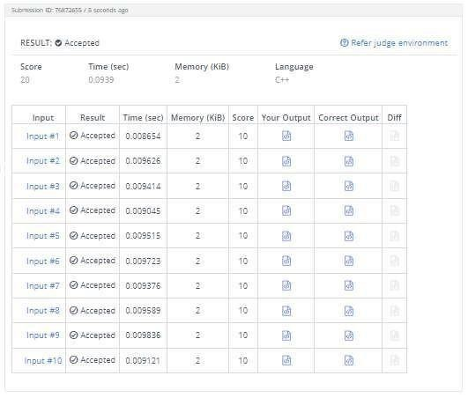

1. **Queens on Board**

**Program Code:**

#include<stdio.h>

#include<string.h> #define MOD 1000000007 int n,m,bit[1

<< 10] ; char g[52][52] ;

int memo2[1 << 15] ; int spread(int mask)

{

if(memo2[mask] != -1) return memo2[mask] ; int nmask = 0 ;

for(int i = 0;i < m;i++)

{

if(mask & 1 << 3 * i) if(i > 0) nmask |= 1 << 3 * i - 3 ; if(mask & 1 << 3 * i + 1) nmask |= 1 << 3 * i + 1 ; if(mask & 1

<< 3 * i + 2) if(i + 1 < m) nmask |= 1 << 3 * i + 5 ;

}

return memo2[mask] = nmask ;

}

int good[50][1 << 8],szg[50],block[50] ; int memo[50][1 << 15] ; int solve(int

x,int mask)

{

if(x == n) return 1 ; mask &= ~block[x] ; if(memo[x][mask] != -1) return memo[x][mask] ;

int ret = 0 ; for(int i = 0;i < szg[x];i++) if(!(good[x][i] & mask))

{

int cret = solve(x + 1,spread(good[x][i] | mask)) ; ret += cret ; if(ret >= MOD) ret -= MOD ;

}

return memo[x][mask] = ret ;

} int solve() { for(int i = 0;i < n;i++)

{ block[i] = 0 ; int cmask = 0 ; for(int j

= 0;j < m;j++) if(g[i][j] == '#')

{

cmask |= 1 << j ; block[i]

|= 7 << 3 * j ; } szg[i] = 0 ; for(int j = 0;j < 1 << m;j++) if((j & cmask) == 0)

{

bool valid = true ; for(int k = 0;k < m;k++) if(j & 1 << k) for(int kk = k + 1;kk < m && g[i][kk] != '#';kk++) if(j & 1 << kk) valid

= false ; if(!valid) continue ;

int sp = 0 ; for(int k = 0;k < m;k++) if(j & 1 <<

k) sp |= 7 << 3 * k ; good[i][szg[i]] = sp ; szg[i]++ ;

}

}

memset(memo,255,sizeof memo) ; memset(memo2,255,sizeof memo2) ; int ret = solve(0,0) ; return

ret ; }

int main(void)

{

for(int i = 1;i < 1 << 10;i++) bit[i] = bit[i >> 1] + (i & 1) ; int runs ; scanf("%d",&runs) ; while(runs--)

{

scanf("%d%d",&n,&m) ; for(int i = 0;i < n;i++) scanf("%s",g[i]) ; int ret = solve()

;

ret = (ret - 1 + MOD) % MOD ; printf("%d\n",ret)

;

}

}

# Output:

